Curriculum Vitae

KEN HOU,LOH

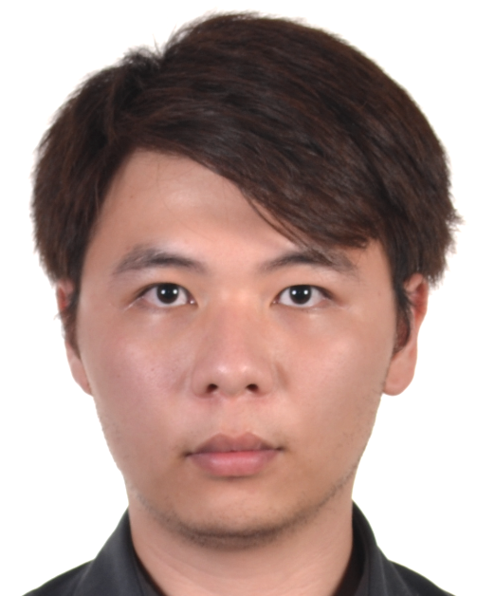

CONFIDENTIAL

No.59 Jalan USJ 11/4K
UEP SUBANG JAYA
47620 Selangor
Malaysia

Phone: (+60) 356372233
Mobile: (+60) 125966225
Email: kenhouloh@gmail.com

PERSONAL DETAILS

NAME Ken Hou, Loh

ADDRESS | No.59 Jalan USJ 11/4K  UEP Subang Jaya  47620 Selangor  Malaysia

TELEPHONE (+60) 125966225

EMAIL kenhouloh@gmail.com
Skype : kenhou1989

LICENCES Drivers Licence

PROFESSIONAL AFFILIATIONS Vice President - RMIT Aerospace, Aviation and Engineering Students Association (AESA) 2009-2011

Member - AIFNA 2010

Member - RMIT Student Union 2009-2011

Treasury - Badminton, Squash &Tennis Club 2005-2006

Member - QuaterMasters 2003-2006

President – Computer Animation and Design 2008-2011

INTERESTS Travelling, Research, Teaching, Networking and Socializing

EDUCATION

RMIT University Bachelor of Applied Science 2009-2011
Melbourne Australia (Aviation)

Ontario Secondary High School College Diploma Ontario Secondary High School
Ontario Canada 2008 Ontario Canada

National Secondary School Subang Utama Secondary Junior and Secondary
High School Selangor Malaysia 2002-2006

National Primary School La Salle Primary School 1996-2001
Selangor Malaysia Selangor Malaysia

Professional Development Activities

Industry Related by RMIT University Professional Development in Aviation

Taylors University College Customer Service and Student Council
Activity Organizer

Competencies Strong Multi-Cultural Understanding &

Knowledge of Aviation & Tourism Industry

Communication Skills
Interpersonal Skills
Multi-lingual (English, Malay, Chinese, Japanese) Language Skills

Time Management
Project Management

Critical Analysis Skills
Developed Research Skills
Efficiency in data collection

Business Oriented Control
Professional Engineering Skills Control

Computer Skills Microsoft 95 – 2007& XP Pro, Vista, 7, Mac
Word / Excel / Power Point / Access /
Internet/ SPSS / 3D Max

Piano Skills Grade 1~5 (Practical and Theory)

CAREER & EXPERIENCE
Full Time
Sept 2012 - Present
Tour Information Research - Selangor Malaysia – MIKI Shared Services Centre (MSSC) Sdn Bhd (sales,
procurement, database, research, communication and quotation)

Full Time
May 2012 - Sept 2012
Assistant Sales and Retail - Kuala Lumpur Malaysia – Hoops Station (sales assistant and retail management)

Part Time
Jan 2010 - Dec 2011
Industry Night 2010 and 2011 - Victoria Australia - RMIT Aerospace, Aviation and Engineering Students Association (AESA) (event organizer)

Full Time & Flexible
June 2009 - Dec 2011
Japanese Association - Melbourne - working experience on merchandise sales and running big events (sales and event organizer)

Full Time
Jan 2008 - Jan 2012
Basic Computer Animation and Design - Kuala Lumpur Malaysia - ECA (Extra Curriculum Activity)

Part Time
Jan 2008 - Dec 2009
Student Council Activity - Kuala Lumpur Malaysia - Student Council Administration

Schooling Days
Jan 2002 - Dec 2006

Student Activity Organizer - Kuala Lumpur Malaysia - Interviewing, Organizing Activities & Data Entry

SELECTED KEY ACHIEVEMENTS

MIKI Travel 2012 until today
- Successfully create new tourism product for network offices and local agents for selected countries
- Greater understanding of travel market segmentation, quotation, researched and create database
- Simplifying projects and presentation among staffs and other departments.
- Supervision skills for new employees
- Create and developed procurements, sales and quotation with support to sales representative
- Successfully circulating and control information flow from suppliers and network offices globally

Bachelor of Applied Science (Aviation) Course 2009-2011
Results on Current Achievements

- Successfully completed all courses and graduate year 2011 with honours.
- Greater understanding of aerospace and aviation industry in having effort on researched by
improving knowledge-based, critical thinking, applying application and enhancing communication skills.

Vice President of Aerospace Student Association (AESA)
- Successfully completed activities and events for students in the aerospace and aviation student
- Having outstanding activities and events for lecturers and events which are beneficial on networking with aerospace and aviation industries.
- Appreciation on effortless in managing the council and association with different universities and globally.

ECA O-Day 2008-2011

- Successfully completed basic computer animation and design and programmes
- Achieved a Certificate of completion with distinctive effort as a President of the Club for Computer Animation and Design and Public Relation with other organizers
Official Awards & Acknowledgements

RMIT Univeristy Graduate Bachelors Degree of Applied Science (Aviation) (BA) 2011
Ontario Secondary High School Student 2008
Certify Community Services Work 2008
Student Award Nomination 2005 in Office Barrel
Student Award 2006 in Culinary Arts (Chef)

- Received a bronze award for culinary art and cook as chef
- Successfully completed Student Award Nomination 2005 in Office Barrel scheme
- Successfully completed 24 hours community services and received certification
- Successfully and received certification recognition for graduation in Ontario Secondary High School
- Successfully graduate and received certification recognition for graduation in RMIT University

REFEREES
Kenichi Yamada
Data & Tariff Manager
k.yamada@group-miki.com

Cho Yosuke
Data & Tariff Supervisor
y.cho@group-miki.com

Junk Mori
Managing Director (MIKI)
j.mori@group-miki.com

Allan
Retail Manager
Hoops Station
summit@hoopsstation.com

Calvin
Supervisor
Japanese Association
(+61) 0421 72 9798

Professor Tom Steiner
Deputy Director Teaching and Learning
RMIT University
School of Aerospace, Manufacturing and Mechanical Engineering
tom.steiner@rmit.edu.au

Professor Glenn Baxter
Course Coordinator and Program Director
RMIT University
School of Aerospace, Manufacturing and Mechanical Engineering
glenn.baxter@rmit.edu.au

Professor George Jiang
Lecturer In Aviation Management
RMIT University
School of Aerospace, Manufacturing and Mechanical Engineering
george.jiang@rmit.edu.au

